|  |
| --- |
| Omnia’s research identifies the key attributes listed below for each of the three positions we are focusing on. Agency owners and managers using the Omnia Profile as part of their hiring process are in an ideal position to benefit from this information. [PIA offers PIA members a discount on the Omnia profile](https://pianet.com/benefits/memberdiscounts/omniaemployeeprofiling) (and a free trial as well).  **Producers**:   * **Assertiveness**: This is the most important characteristic for producers. Successful producers play-to-win and are proactive, assertive, competitive, driven, highly ambitious, incentive based, career growth oriented, risk-takers, want rewards based on their own successes, comfortable negotiating and closing deals, confident. * **Communication and Problem-Solving Style**: C/l producers often strike a balance between sociability and analysis of facts; p/l producers are more socially oriented. Both sociability and analysis-oriented producers can be successful with different types of prospects. * **Pace**: Tend to be fast-paced, strong sense of urgency, comfortable working under tight deadlines, dealing with the unexpected and multitasking. * **Structure**: This is the second most important characteristic for producers. Successful producers are resilient/can handle rejection, are comfortable working with little to no structure, can handle ambiguity, focus on results—but not always great at details.   **Non-selling, service-only CSRs**:   * **Assertiveness**: Risk-averse, nonassertive, very helpful, supportive, avoids confrontation, team oriented, cooperative, focused on providing quality service and gaining customer satisfaction, service-oriented. * **Communication and Problem-Solving Style**: Task-oriented, serious, practical, focused, able to concentrate on data-intensive activities, analytical problem-solvers, good listeners, ask clarifying questions, inquisitive. * **Pace**: Patient, persistent, willing to focus on lengthy or repetitive tasks, okay with routines, thorough and systematic, some sense of urgency is OK. * **Structure**: Structure versus autonomy, a strong concern for quality and compliance, attention to detail, comfortable working within clearly defined boundaries, accurate and well organized.   **Selling CSRs (aka CSAs)**:  Similar to servicing CSRs but more assertive with a sense of urgency   * **Assertiveness**: Self-confidence, initiative-taking behavior, helpful, team oriented. * **Communication and Problem-Solving Style**: Task-oriented, serious, practical, focused, able to concentrate on data-intensive activities, analytical problem-solvers, good listeners, ask clarifying questions, inquisitive. * **Pace**: Tend to be fast-pace, strong sense of urgency, comfortable working under tight deadlines, dealing with the unexpected and multitasking. However, a moderate degree of patience enables these individuals to work better with clients needing lots of time and in a repetitive environment. * **Structure**: Attention to detail, works best in a structured role with clear guidelines. If they have sales quotas, look for individuals who can operate more independently and are resilient/can handle rejection. |

**Resource from Omnia**

**Attributes for Successful Producers and Selling/Servicing CSRs**

**One Assessment. Eight Columns. Unlimited Potential…**

**How to use the power of behavioral insight to select top agency talent**

The Omnia Profile, a simple yet amazingly accurate behavioral assessment, provides agencies with insight into the workplace aptitudes of candidates and employees. It’s fast, just 10 minutes and easy, no confusing questions or irrelevant multiple choice scenarios. It’s based on extensive research in the prediction of behavioral characteristics through adjective checklists and psychometric analysis.

Omnia Insurance Targets are designed to help agencies hire and keep the best. The benchmarks are derived from our practical research of the insurance industry and the specific jobs within the industry using profiles of proven top performers, position competencies, years of consulting data, and job descriptions within our database.

By complementing an agency’s existing selection strategies, the Omnia assessment provides an early glimpse into behavioral issues that may not be apparent until long after you hire someone. Agencies can make more informed hiring decisions, decrease turnover and increase retention to improve ROI.

People who take the Omnia Profile choose words from a list of adjectives to describe themselves. The hiring manager is delivered a graphical depiction of the candidate’s workplace traits. These results are a helpful way to match candidates with the job and culture, which means less turnover and happier employees (re: higher production and more profit). It can also help develop and coach existing employees, plan succession, help with communication or deal with difficulties between staff members (more on that later).

**The Omnia Producer Benchmark**

There’s nothing worse than a candidate who appears to be articulate and confident in the interview, but once on the job, they just can’t close. Don’t make the mistake of thinking you can teach the art of sales to someone who isn’t a natural seller. You may be able to coach them, but if they can’t bring themselves to close the deal, you’ve got a big problem.

Producers are the revenue generators, and the ones with sustainable sales success all share certain behavioral components. Based on Omnia’s benchmark research, a Producer target has been established and proven to work time and time again.

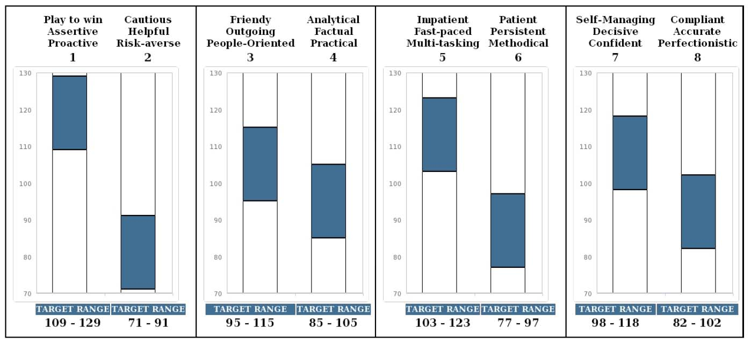

**Assertiveness**

It’s probably obvious that naturally assertive people will bring in the most business. Most successful producers have a high degree of assertiveness, which is shown as a tall column 1 on the Omnia bar graph. Individuals with a high degree of assertiveness are competitive, driven, and highly ambitious. They are motivated by an incentive-based salary structure. They want to grow professionally, take charge of their own earning destiny and gain financial rewards based on their successes. They are risk-takers, and this translates to comfort with negotiating, asking for a prospect’s business and having the majority of their pay commission driven. They would rather earn more for their accomplishments than work under a stable salary structure. The opportunity for unlimited income growth is a more powerful motivator than the security of a fixed check every payday. They have the confidence to overcome obstacles and influence the actions and decisions of those around them. They can firmly manage sales negotiations and proactively go for the close.

**Communication and Problem-Solving Style**

This can go either way. Picture sales like baking a cake; there are “ingredients” you need to produce a cake worth eating, like sugar and flour. For sales, assertiveness is a necessary ingredient, but sociability and/or fact-drive are flavorings. They impact the sales style, but they do not typically keep someone from selling. Our studies show that a balance of sociability and analysis is ideal for commercial lines producers while more sociability is often found in personal lines producers. Sociability (column 3) indicates how outgoing, people-oriented and verbally expressive an individual tends to be. Column 4 measures analytical qualities and task focus. Socially expressive sellers often excel at building rapport, nurturing relationships and connecting on a personal or emotional level with prospects. Analytical sellers often excel at building value, solving problems and connecting with prospects using problem solving. Both styles can be extremely valuable and both will appeal to certain types of prospects. Knowing what type of producer you have will help in so many ways, including areas for development and coaching.

**Pace**

Here’s another trait that is not a critical ingredient to sales ability but can be important depending on the pace of your agency and sales cycle. Most successful producer personalities are fast paced. They have a strong sense of urgency, and they want to take immediate action to capitalize on opportunities. They are comfortable working under tight deadlines, managing competing demands at one time, and dealing with the unexpected. Sales is a field that moves quickly, and naturally urgent people are motivated by the variety and time pressure of selling. They have the flexibility for busy environments. They are multitasking and enjoy being involved in various activities or initiatives at once.

**Structure**

While assertiveness is often the single most critical ingredient to sales success, this trait plays a close second. It has been shown to contribute to overall sales success because this is where you find resilience; the ability to brush off rejection and move on to the next opportunity with confidence. No one likes rejection of course, but some people move past it quickly while others tend to dwell on it and lose confidence. You obviously want producers who can move past it with ease. On the Omnia benchmark this means a taller column 7 than 8 or just a little bit of 8, but too much and the problem with rejection becomes a noticeable impediment to sales. Some other things you get with an autonomous sales person is comfort working with little to no structure. Your target producer can make decisions in unclear situations and handle ambiguity with confidence. They focus on the results not the processes, so attention to detail isn’t always the greatest. Thank goodness for good CSRs! Let’s talk about them next.

**The Omnia CSR Benchmark**

Your CSR candidate might look good on paper, but what if they don’t engage well with your customers or have difficulty dealing with stressful environments. That’s going to be a major problem in the customer-centric insurance world. Being impatient and lacking the interpersonal skills to explain policy limitations and coverages or answer innocent questions could cause a potential customer to walk out the door and down the street to your competitor’s agency. And what about attention to detail? Remember how we said this is often lacking in producers? If producers need assertiveness to sell (and they do), then CSRs need attention to detail to service. It’s a must.

Based on Omnia’s benchmark research, a non-selling or traditional CSR target has been established and is a great predictor of strong service performance.

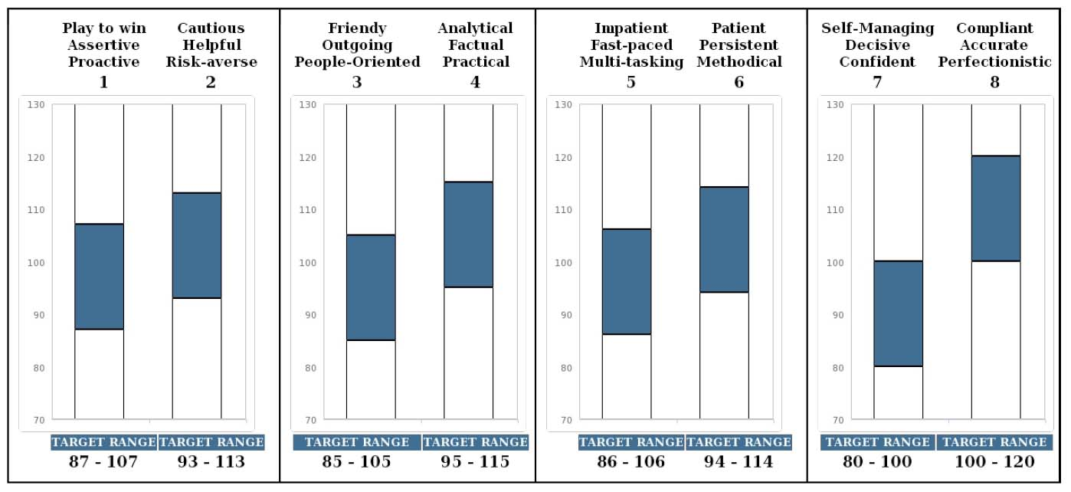

**Assertiveness**

Naturally risk-averse people are excellent service personalities. They are helpful, supportive and team oriented. And while they may not look for every chance to sell, they will keep your customers happy.

The CSR target benchmark, derived from top proven CSRs in the insurance industry, has a high degree of caution versus assertiveness. This means the target CSR is supportive and avoids confrontation. There is often a strong concern for helping customers and a tendency to place great value on the idea of cooperation and harmony. A CSR requiring reactive behaviors (answering incoming calls, processing insurance policy applications, or assisting customers with changes and cancellations) is best filled by nonassertive personalities. They are supportive of co-workers and customers, and focused on providing quality service and gaining customer satisfaction. They are helpful, service-oriented and eager to work cohesively with producers and managers to achieve service objectives.

**Communication and Problem-Solving Style**

The target agency CSR is task-oriented, serious and practical. These individuals complete their work with good focus and can concentrate on data-intensive activities for long periods of time. These individuals are analytical problem-solvers who objectively gather information, determine the best plans/coverage options, and evaluate customers' insurance needs using listening techniques and clarifying questions. They are inquisitive and pragmatic for collecting and researching account information. They provide customers with concise, through feedback. For them, interacting with customers is more about informing than about building relationships.

CSRs with a balance of sociability and analytical aptitude present information in a logical, factual manner. They remain focused on asking pertinent questions to evaluate customers’ needs but will also attempt to build a personal connection with them.

**Pace**

The target CSR has more patience than urgency, though both types can be strong representatives. These methodically paced CSRs are patient, persistent, and willing to focus on lengthy or repetitive tasks without becoming easily distracted. They are comfortable following a predictable routine and completing one task at a time. They focus on being thorough and systematic when helping customers rather than rushing through calls or processes.

A higher degree of urgency often means more flexibility and an ability to adapt quickly to new situations. A fast-paced CSR comfortably juggles multiple assignments and responds to customer requests and tight deadlines with a sense of urgency.

A balance of patience and time-sensitivity suggests an even working pace. There is some urgency for completing calls, but that is balanced with persistence for solving lengthy problems or following through on tedious/repetitive tasks.

The important thing about pace is that top CSRs are not extreme in either direction.

**Structure**

A high degree of structure versus autonomy is often a critical trait for successful CSRs. Agency CSRs have a strong concern for quality and compliance, as well as natural attention to detail. The taller the column 8 of the individual, the stronger the attention to detail and concern for following guidelines and procedures when assisting customers. Target CSRs value structure and are comfortable working within clearly defined boundaries. Compliance is often a strong characteristic. They are cooperative and comfortable in a structured work environment. More importantly, they are accurate when entering data, processing paperwork, or handling other detailed tasks for your customers. There is a strong concern for meeting manager/producer expectations and staying well organized.

In summary, your target CSRs are helpful, risk-avoidant, analytical, accurate and by-the-book.

**The Omnia Selling CSR Benchmark**

Basically, take everything we said for the CSR and add some assertiveness and urgency to get a strong Selling CSR candidate. Traditional CSRs are great and their ability to move processes along, catching and correcting details along the way, is extremely important. But, if you are looking to proactively build revenue in your service team, then you need a selling CSR personality. This personality type has strong attention to detail, which isn’t ideal for sales but crucial for service, as well as more assertiveness than a typical CSR. It’s this assertiveness that builds an awareness of sales opportunities within the service cycle and the initiative to capitalize on those opportunities.

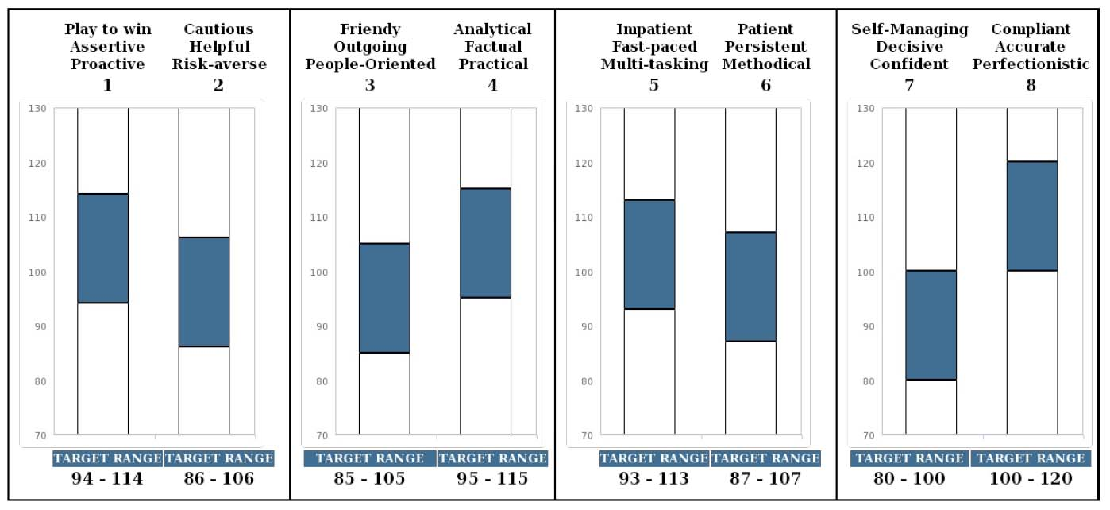

**Assertiveness**

A good level of assertiveness means self-confidence and initiative-taking behavior. The target selling CSR takes advantage of opportunities to sell insurance by making additional coverage recommendations to clients, and engaging in account-rounding and x-dating functions. But the assertiveness is not so strong that you lose the helpfulness and team outlook necessary to perform the most critical aspects of agency service work. However, if your agency follows a hybrid sales/service model with definitive sales goals for the service reps, then a higher degree of assertiveness is important.

**Communication and Problem-Solving Style**

Like a traditional CSR, selling CSRs are also task-oriented, serious and practical. They work with good focus and can concentrate on data-intensive activities for long periods of time. They are analytical problem-solvers who objectively gather information, determine the best plans/coverage options, and evaluate customers' insurance needs using listening techniques and clarifying questions. They are inquisitive and pragmatic for collecting and researching account information. They provide customers with concise, thorough feedback. For them, interacting with customers is more about informing than about building relationships. Still, those with a higher degree of sociability can make personal connections when suggesting additional coverage and products.

**Pace**

Most successful sales personalities are fast paced. They have a strong sense of urgency, and they take immediate action to capitalize on opportunities. They are comfortable working under tight deadlines, managing competing demands at one time, and dealing with the unexpected. Positions involving revenue quotas and a reset of goals each month are best filled by individuals who are motivated by variety and time pressure. However, a moderate degree of patience can work just as well. CSRs with more patience than urgency will follow through on lengthy tasks, work persistently with customers needing significant time and attention, and work comfortably in a repetitive or highly predictable environment.

**Structure**

A high degree of attention to detail is necessary in service roles. CSRs are often the ones managing the details so the producers can focus on new business generation. So like the traditional CSR, the standard selling CSR benchmark has a high degree of attention to detail and works best in a structured role with clear guidelines. However, if your agency follows a hybrid sales/service model with definitive sales quotas for the service reps, then a higher degree of independence is important; this translates to resilience for managing rejection. In that case, the ideal benchmark has a balanced column 7 (autonomy) and 8 (structure, attention to detail).

Other agency benchmarks available through Omnia are claims representative, loss control consultant and underwriter. There are also tools for general leadership and administrative/clerical positions.

Behavioral assessments provide you with advance knowledge of a candidate’s strengths and challenges to make more informed, and therefore better, hiring decisions.

